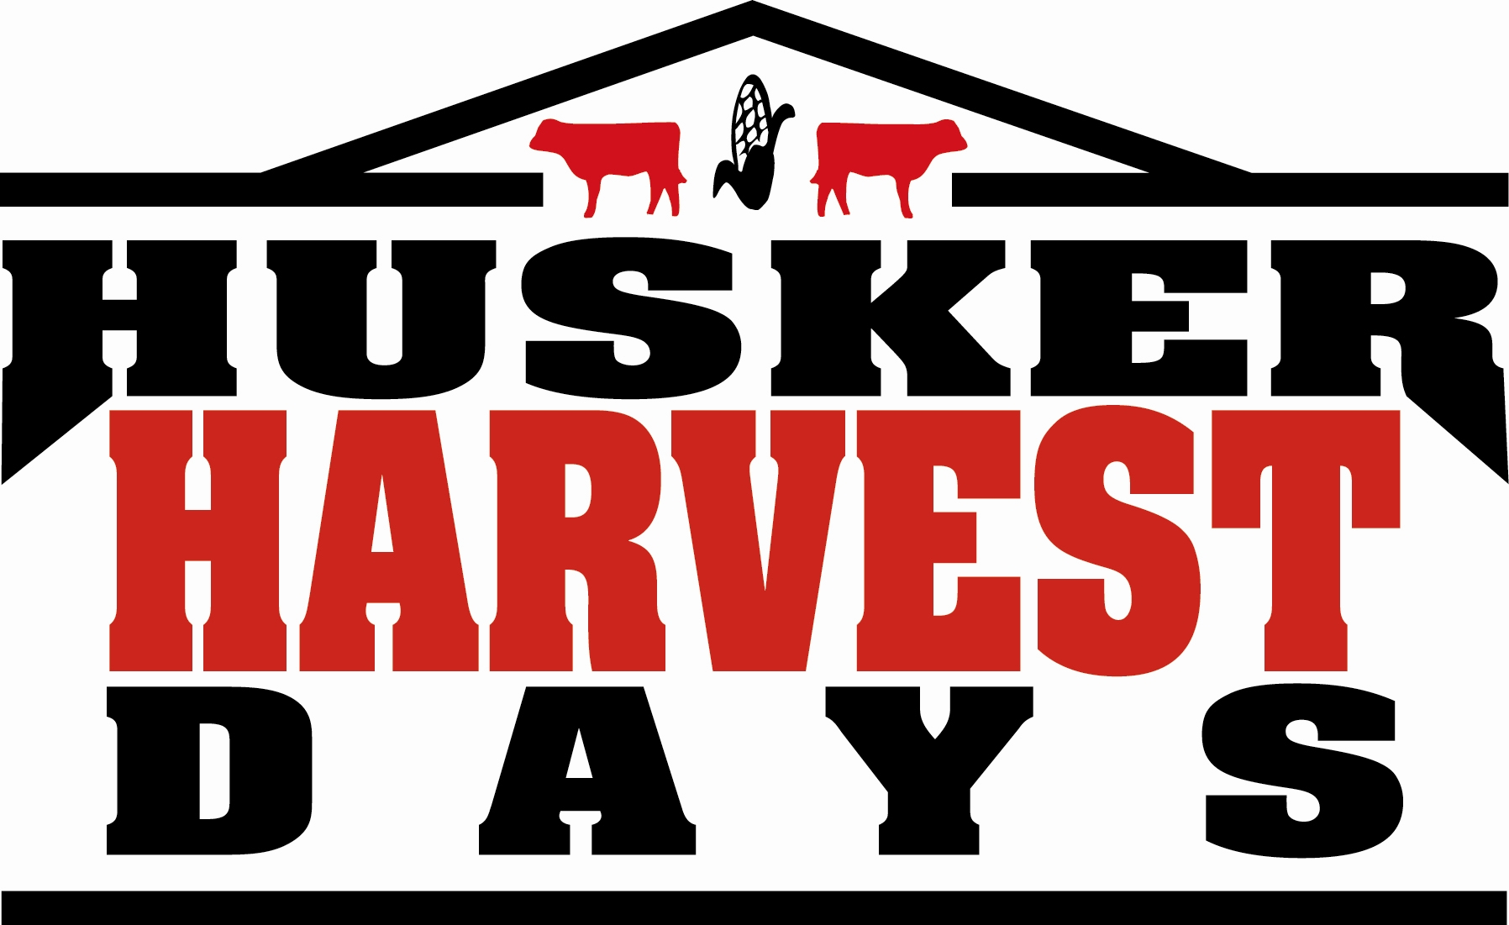

Husker Harvest Days Scholarship

Nine scholarships valued at $1,200 each for students pursuing a post-secondary education in various areas of the field of agriculture to be awarded by the Agricultural Institute of Nebraska, Grand Island Chamber of Commerce, and Farm Progress Companies.

The scholarships are awarded to high school graduating seniors who are pursuing a program/career in agriculture/agribusiness. All scholarships are academic in nature. Financial need may be a consideration in the selection process but will not be the determining factor.

Five scholarships must be given to applicants from the counties of Buffalo, Hall, Hamilton, Howard, and Merrick. The remaining four scholarships will be awarded statewide and may include the above named counties. The scholarships will pay $1,200 per school year with $600 paid for the first semester or quarter upon proof of registration and $600 for the second semester or quarter upon proof of maintenance of a 2.5 grade point average during the first semester or quarter.

Selection Process: Applications MUST BE POSTMARKED by March 20, 2020. NO LATE APPLICATIONS WILL BE ACCEPTED.
Scholarships determined April 2020

Eligibility:
- Applicant must have a “B” average or above.
- Applicant must complete the designated scholarship form.
- Successful applicants must agree to submit a brief summary that describes his/her first semester participation in college and how this scholarship benefitted your education.
- The scholarships MUST be used at any accredited university, 2-4 year college, or technical school in Nebraska and be enrolled in a program relating to agriculture/agribusiness.

Husker Harvest Days Scholarship
(Please Type)
Name _________________________________________County of Residence ___________________________
Address ________________________________________City________________________Zip_____________
Telephone ( ) - Social Security Number ____________________________
Email Address _______________________________________________________________________________
Name of High School ________________________Guidance Counselor’s Name & Email___________________
Address City Zip
Newspaper serving area & email
Address ________________________________ City Zip
Name of Parent(s) or Guardian _________________________________________________________________
Address (if different from above) _______________________________________________________________

Name of 2-4 year college, university or technical school you plan to attend
(you must plan to enroll in a program of study related to agriculture):

__________________________________________________________________________________________

Anticipated field of study: __________________________________________________________________

Why have you chosen this field of study?_______________________________________________________

__________________________________________________________________________________________

__________________________________________________________________________________________

__________________________________________________________________________________________

__________________________________________________________________________________________

__________________________________________________________________________________________

List anticipated college costs for the next year:
Tuition: $ ___________________________
Books: $ ____________________________
Room and Board: $ ___________________

On a separate piece of paper, please type the answers to the following questions. Limit answers to 200 words.

- Describe your participation in school activities and organizations, including accomplishments and awards:

- Describe your participation in civic, church and other activities, including accomplishments and awards:
- What other scholarships have you applied for and/or received?
- Have you attended the Husker Harvest Days Show? If so, what has been your participation?

REQUIREMENT: Attach a resume (2- page maximum) to the application. This resume should include the listing of activities and work experience throughout your high school years. No supplement pages other than resume.

STATEMENT OF SCHOOL COUNSELOR

I certify that the applicant is on course for graduation in 2020, has a "B" average or above, and is in good standing in our school.

National Testing Scores:
SAT ACT

Counselor Signature ________________________________________ Date___________________

STATEMENT OF APPLICANT
If selected to receive this scholarship, I agree to allow the Agricultural Institute of Nebraska and Nebraska Farmer release press information pertaining to my application.

Yes _____ No _____

I certify that all information given on this application is true, correct and complete to the best of my knowledge.

Applicant Signature __________________________________ Date_____________________

PLEASE RETURN COMPLETED APPLICATION BY MARCH 20, 2020 TO:
Husker Harvest Days Ag Scholarships
ATTN: Cindy Johnson
Grand Island Chamber of Commerce
309 W 2nd Street
Grand Island, NE 68801

